# Project Documentation Phase 2

Event Management & Ticketing System on Salesforce

## Phase 2: Org Setup & Configuration

👉 **Goal:** To prepare the Salesforce environment through setup and configuration to support the Event Management & Ticketing System.

### 1. Salesforce Editions

* **Edition Used:** Salesforce Developer Edition (Dev Org) – free, full-featured org for testing and configuration.
* **Rationale:** Suitable for project prototyping, customizations, and testing before moving into production.

### 2. Company Profile Setup

* **Company Name:** Event Management & Ticketing System
* **Default Locale:** English (India)
* **Currency:** Indian Rupee (INR) – primary, with USD enabled for external partners.
* **Default Time Zone:** Asia/Kolkata (IST).
* **Business Address:** Event organizer’s HQ address (configurable).

✅ Configured Organization Name, Locale, Time Zone, and Currency.  
✅ Enabled INR as primary currency for domestic users and USD for international attendees/sponsors.  
✅ Prepared base org settings.

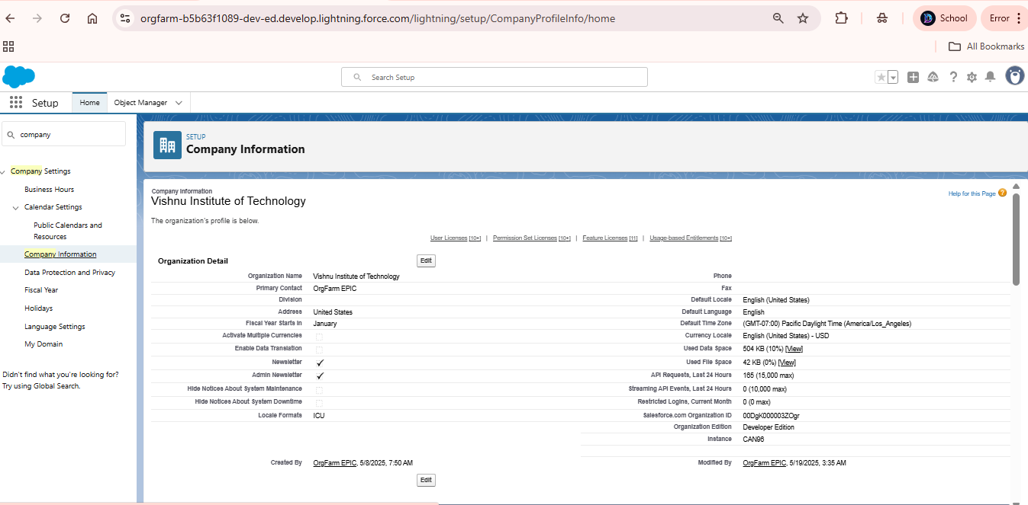

### 3. Business Hours & Holidays

* **Standard Business Hours:** 9:00 AM – 6:00 PM IST (Monday–Saturday).
* **Holidays Configured:** Republic Day (26 Jan), Independence Day (15 Aug), Gandhi Jayanti (2 Oct), Diwali & Local Holidays.
* **Purpose:** Ensures approvals, escalations, and event notifications respect real business days and timings.

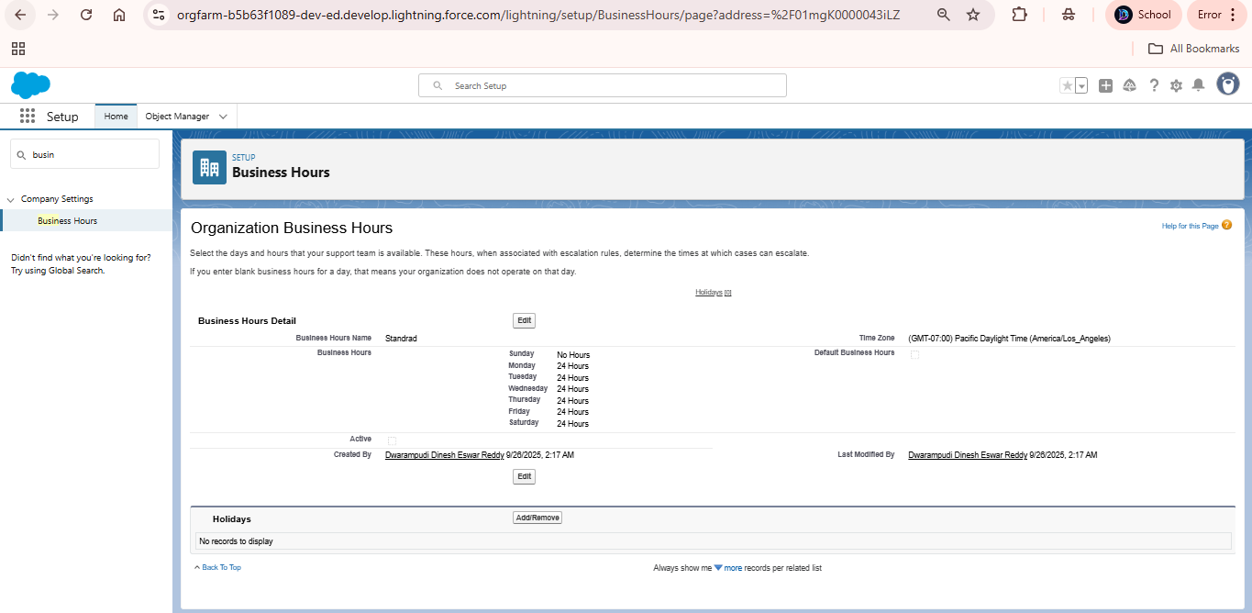

### 

### 4. Fiscal Year Settings

* **Type:** Standard Fiscal Year (Jan–Dec).
* **Reason:** Aligns with event industry financial and sponsorship cycles.
* **Future:** Custom fiscal year can be enabled if required by corporate sponsors.

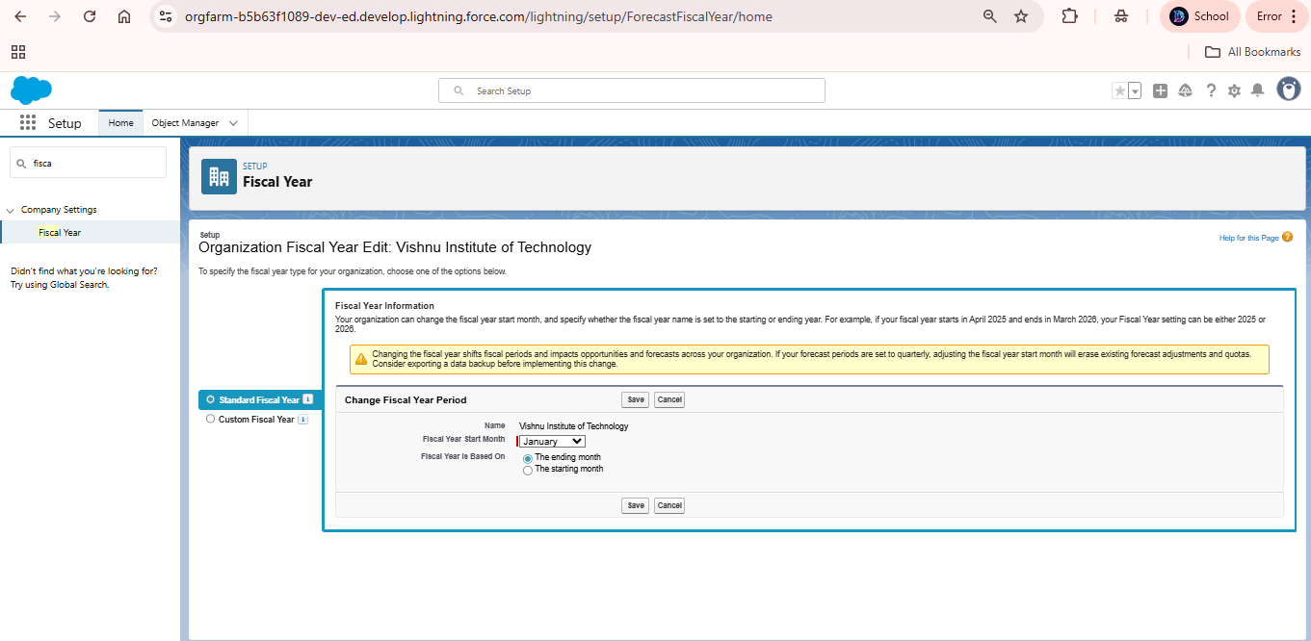

### 5. User Setup & Licenses

**User Types Configured:** 1. **Attendee User** (Community/Experience Cloud License) → Register and manage tickets.  
2. **Organizer User** (Salesforce Platform License) → Manage events, ticketing, and dashboards.  
3. **Ticketing Staff User** (Salesforce Platform License) → Manage attendee check-ins and support.  
4. **Sponsor User** (Community/Experience Cloud License) → View sponsorship benefits and reports.  
5. **System Admin User** (Salesforce License) → Manage overall Salesforce Org.

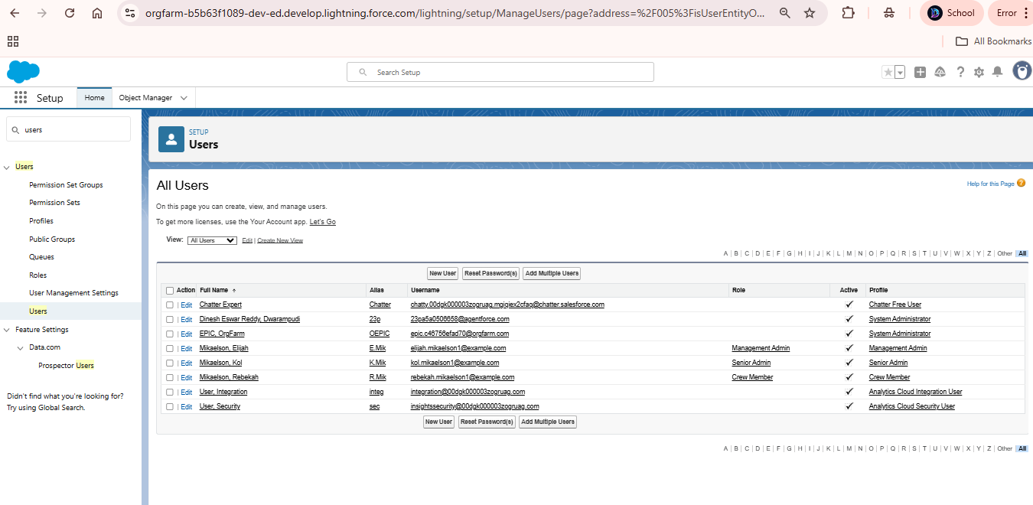

### 

### 6. Profiles

* **Attendee Profile:** Limited access (view tickets, register for events, update personal info).
* **Organizer Profile:** Can create/manage events, tickets, dashboards.
* **Staff Profile:** Manage attendee check-in and ticket validation.
* **Sponsor Profile:** Read-only access to event and attendee reports.
* **System Administrator:** Full org access.
* 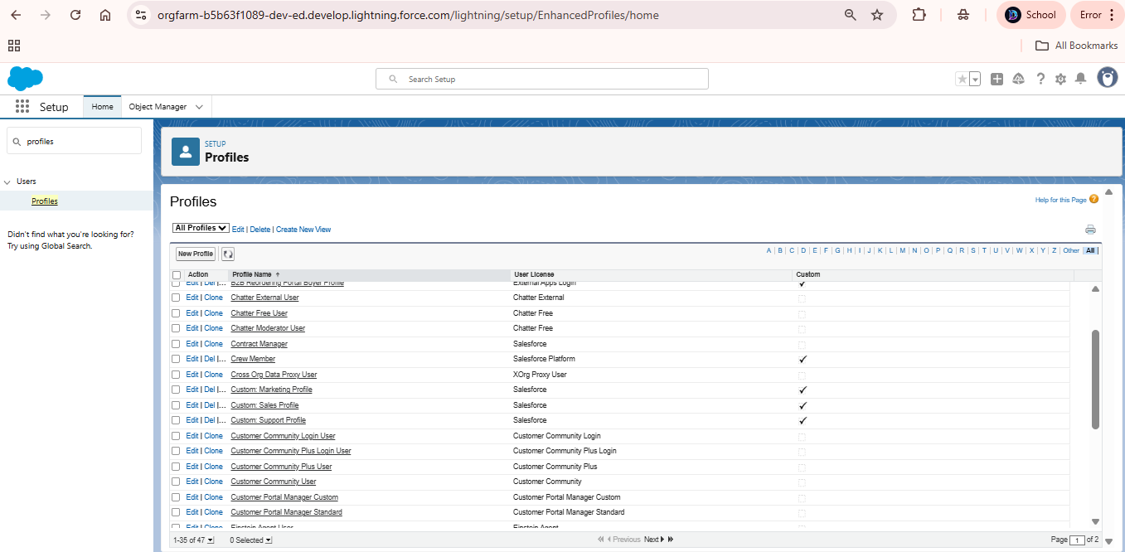

### 7. Roles

**Hierarchy Setup:** - System Admin (Top).  
- Organizers (Event Managers).  
- Ticketing Staff.  
- Sponsors.  
- Attendees.

📌 Ensures role hierarchy visibility (e.g., Organizer can see all event and ticket data, but attendees see only their own records).

### 

### 

### 8. Permission Sets

**Additional Access via Permission Sets:** - **Reporting_Access:** For Organizers to create/modify reports.  
- **Analytics_Access:** For Sponsors to view dashboards.  
- **Checkin_Access:** For Staff to update attendee check-in status.  
- **Event_Creation_Access:** For Organizers to manage event records.

✅ Assigned permission sets to users as per role requirements.

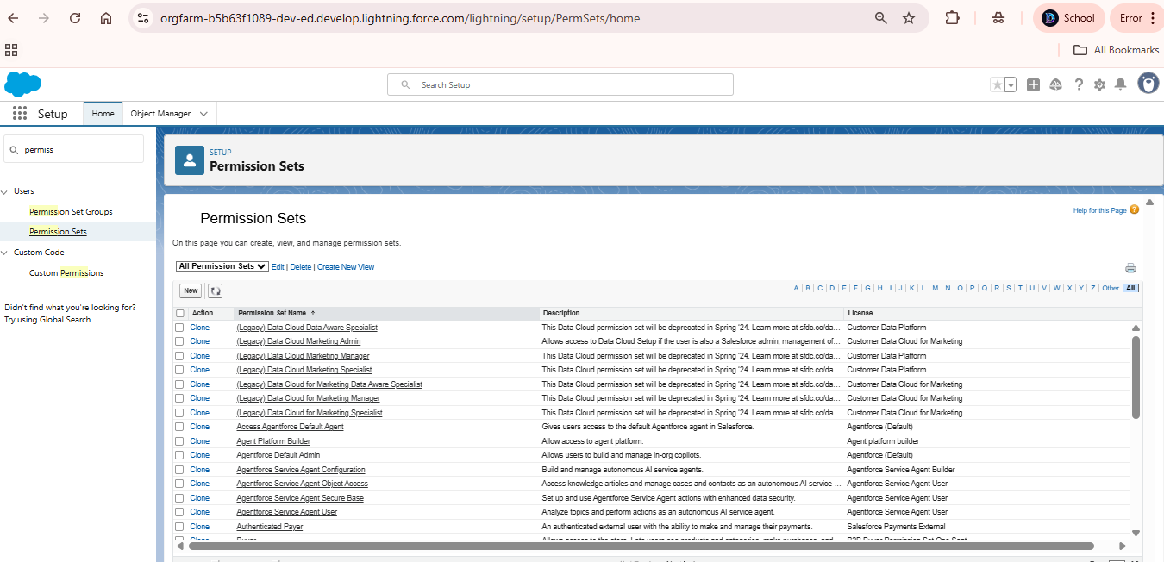

### 9. Org-Wide Defaults (OWD)

* **Event Data:** Public Read Only – everyone can see published events.
* **Ticket Data:** Controlled by Parent (linked to Event).
* **Attendee Records:** Private – visible only to attendee and admins.
* **Sponsor Reports:** Read-Only – restricted to sponsor users.

### 10. Sharing Rules

* Organizers can view and manage all event and ticket data.
* Staff can update check-in status for attendees of their assigned events.
* Sponsors can view high-level dashboards (sales & demographics).

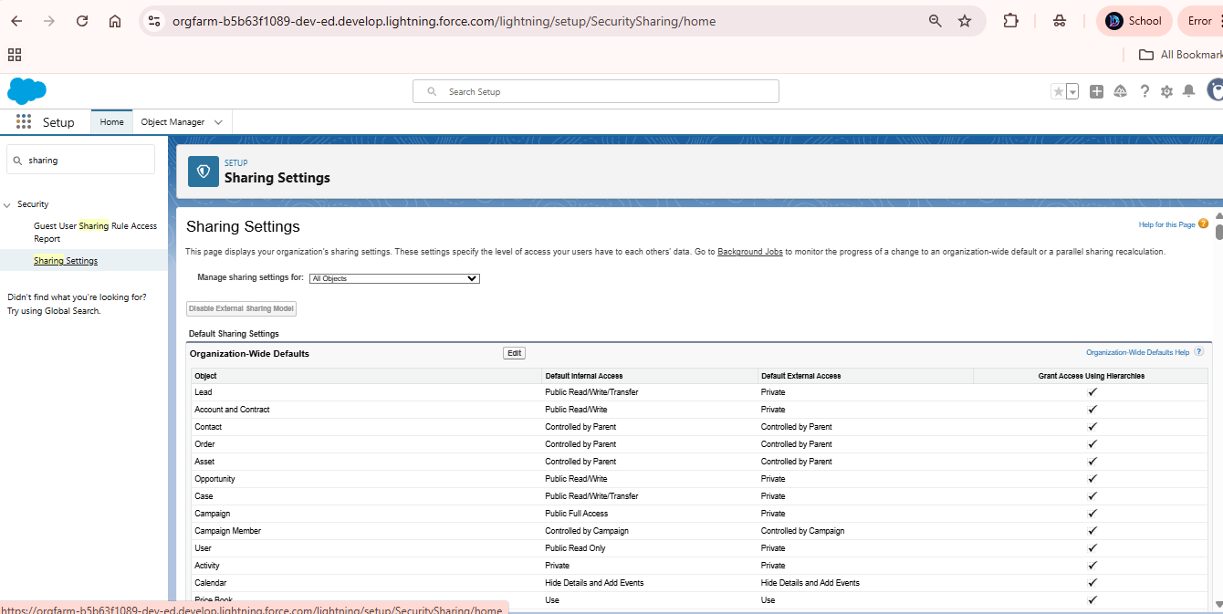

### 11. Login Access Policies

* Restrict attendee logins to **6 AM – 11 PM IST**.
* Enforce **IP restrictions** for organizer staff and admins.
* Enable **2FA (Two-Factor Authentication)** for system admins.

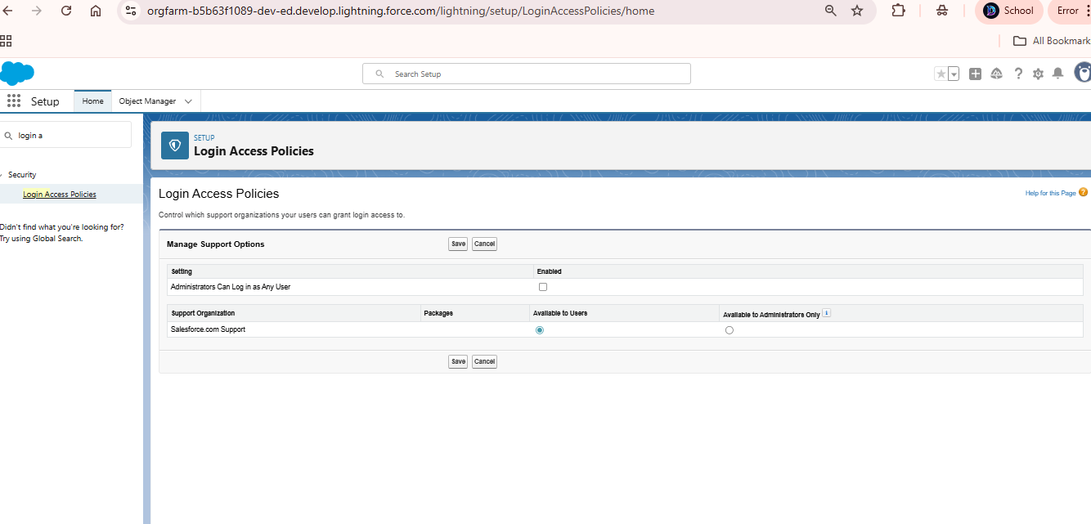

### 12. Dev Org Setup

* Created free Salesforce Developer Org as baseline.
* Enabled **Experience Cloud** (for attendee portal).
* Installed **VSCode + SFDX CLI** for implementation.
* Setup GitHub repository for version control.

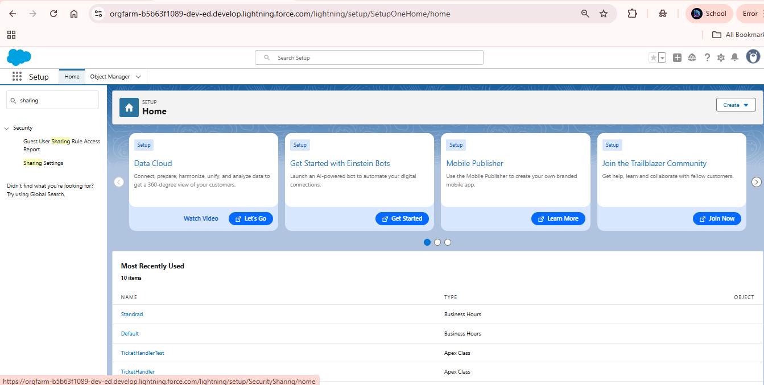

### 13. Sandbox Usage

* **Developer Sandbox** for testing.
* For production scale: Full Sandbox for UAT, Partial Sandbox for training/demo data.

### 14. Deployment Basics

* Configurations and custom objects built in Dev Org/Sandbox.
* Deployment to Production via Change Sets (profiles, roles, flows, objects).
* Version control with GitHub (for Apex classes, Lightning components).

✅ **Phase 2 Deliverable:**  
By the end of Phase 2, we have: - Configured company setup, users, profiles, roles, and OWDs.  
- Enabled Experience Cloud portals for attendees and sponsors.  
- Setup security, login policies, and sharing models.  
- Prepared sandbox & deployment plan for upcoming phases.